1. *Tracing - Trace is a unique component that distinguishes observability from other monitoring mechanisms. It helps SRE/DevOps teams quickly understand and scrutinize the technical glitches that cause infrastructure disruption.*

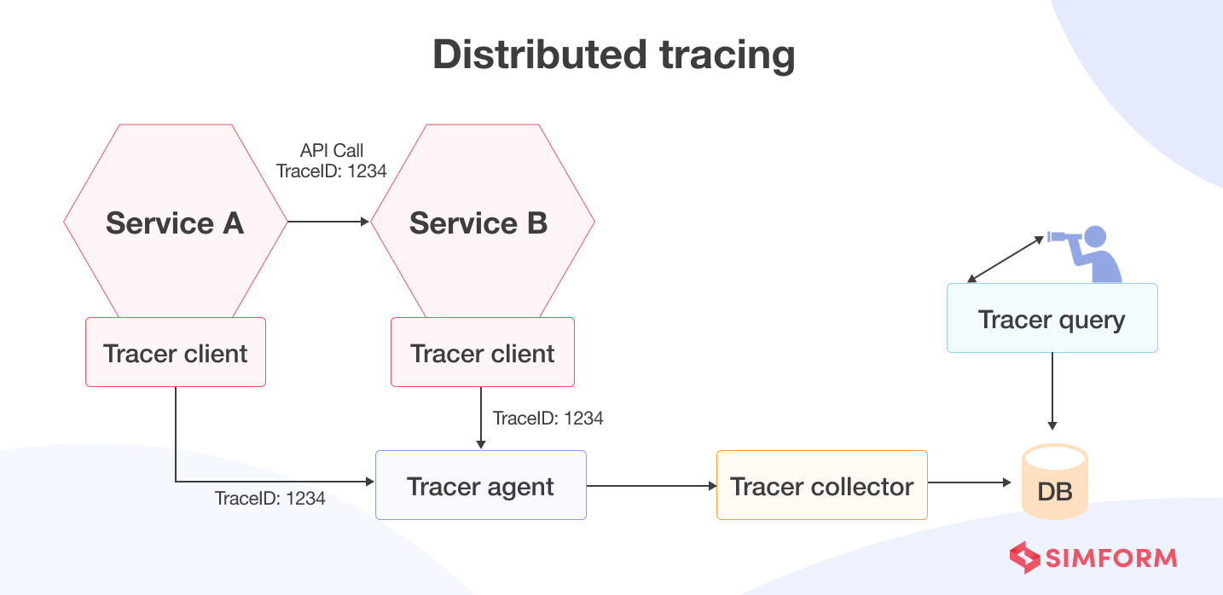

*Benefits of distributed tracing are:*

* *Provides information about various service dependencies in a microservice architecture.*
* *Ensures resiliency and fault tolerance in case of system failures.*
* *Ensures end-to-end visibility across distributed infrastructure.*

*How does distributed tracing facilitate observability?*

*Microservices scale independently. Therefore, there are usually multiple iterations of a single service running across different servers. Because hundreds of such services run simultaneously, getting visibility into each interaction becomes nearly impossible. As a result, evaluating whether the services are running correctly becomes a challenging task.*

*Distributed tracing solves this problem by automatically tracking requests through each service or module and providing end-to-end visibility through distributed infrastructure.*

*Distributed tracing helps to understand users’ journeys and how they interact with each service. It traces all the touchpoints, including every user’s location, their interaction with other.* ***Root cause analysis is one of the core promises of observability****, and distributed tracing does precisely that.*